

**UTTARA UNIVERSITY**

**DESIGN & DEVELOPMENT OF EDUCATION PORTAL**

**BY**

|  |  |  |
| --- | --- | --- |
| **MD RAJIB MRIDHA** | **ID 2161081100** | **BATCH (38th B DAY)** |
| **MD ARMAN HOSSAIN** | **ID 2161081117** | **BATCH (38thB DAY)** |
| **MUNIRA MUNMUN MIM** | **ID 2161081118** | **BATCH (38thB DAY)** |
| **JANNATUN NESSA RUSHNI** | **ID 2161081119** | **BATCH (38thB DAY)** |

DEPARTMENT OF COMPUTER SCIENCE AND ENGINEERING   
SCHOOL OF SCIENCE AND ENGINEERING   
UTTARA UNIVERSITY

FALL 2019



**UTTARA UNIVERSITY**

**DESIGN & DEVELOPMENT OF EDUCATION PORTAL**

**BY**

|  |  |  |
| --- | --- | --- |
| **MD RAJIB MRIDHA** | **ID 2161081100** | **BATCH (38th B DAY)** |
| **MD ARMAN HOSSAIN** | **ID 2161081117** | **BATCH (38thB DAY)** |
| **MUNIRA MUNMUN MIM** | **ID 2161081118** | **BATCH (38thB DAY)** |
| **JANNATUN NESSA RUSHNI** | **ID 2161081119** | **BATCH (38thB DAY)** |

A project submitted in partial fulfillment of the requirement for the degree of Bachelor of Science in Computer Science and Engineering

Department of Computer Science and Engineering   
School of Science and Engineering   
Uttara University, Uttara, Dhaka, Bangladesh

Fall 2019

**ABSTRACT**

Education portal system means the use of computer and Internet technologies to deliver a broad array of solutions to improve teaching-learning performances. Nowadays, most of the academic institutions are using education portal system because it is efficient and low cost. It helps the learners by providing new learning opportunities to achieve the ultimate goals according to their environment. Currently, learning is no longer confined to classrooms with traditional lecture delivery. The main objective of education portal is to facilitate education by using communication media through internet which made learning possible from anywhere at any time. The main purpose of this project is to design and develop of education portal system to add values in teaching-learning technology. This project will allow various stages for developing specific courses and related resources. As the project will be developed based on open source platforms, it will satisfy the user requirements and allow them to reuse, study, and distribute. The potential outcome of this project will be able to accommodate all kinds of academia and improve the teaching-learning environment through the integration of the proposed system with the traditional education system.

***Keywords:*** *Education portal system, Learning system, Teaching-learning environment, Open source platform, E-education system.*

**APPROVAL**

We certify that we have supervised this project and read this manuscript. In our opinion, it conforms to acceptable standards of scholarly presentation and is fully adequate, in scope and quality, as a report for the degree of BSc. in Computer Science and Engineering.

Md Akhtaruzzaman

Supervisor

A.H.M Saifullah Sadi

Co-Supervisor

I certify that I have read this study. In my opinion, it conforms to acceptable standards of scholarly presentation and is fully adequate, in scope and quality, as a thesis for the degree of BSc. in Computer Science and Engineering.

Md Akhtaruzzaman

Coordinator/Internal Examiner

This project report was submitted to the Department of Computer Science and Engineering and is accepted as a fulfillment of the requirement for the degree of BSc. in Computer Science and Engineering.

Md. Mijanur Rahman

Chairman, Dept. of CSE

**DECLARATION**

We hereby declare that this report is the result of our own investigations, except where otherwise stated. We also declare that it has not been previously or concurrently submitted as a whole for any other degrees at Uttara University or any other institutions. We also declare that the formatting of the manuscript is same as the provided template. We also do not have any objections for the further use of the manuscript as Uttara University has all the rights to update, publish, or conduct further research of the submitted work.

|  |  |  |  |
| --- | --- | --- | --- |
| **Student Names** | **Student IDs** | **Signature** | **Date** |
| **MD RAJIB MRIDHA** | **ID 2161081100** | ______________ | _______________ |
| **MD ARMAN HOSSAIN** | **ID 2161081117** | ______________ | _______________ |
| **MUNIRA MUNMUN MIM** | **ID 2161081118** | ______________ | _______________ |
| **JANNATUN NESSA RUSHNI** | **ID 2161081119** | ______________ | _______________ |

|  |
| --- |
| UTTARA UNIVERSITY  INTERNATIONAL ISLAMIC UNIVERSITY MALAYSIA  **DECLARATION OF COPYRIGHT AND AFFIRMATION OF FAIR USE OF UNPUBLISHED RESEARCH**  **DESIGN & DEVELOPMENT OF EDUCATION PORTAL**  We declare that the copyright holders of this dissertation are jointly owned by the students and Uttara University (UU).  Copyright © 2019 Md. Rajib Mridha, Md. Arman Hossain, Munira Munmun Mim,  Jannatun Nessa Rushni and Uttara University (UU). All rights reserved.  No part of this unpublished research may be reproduced, stored in a retrieval system, or transmitted, in any form or by any means, electronic, mechanical, photocopying, recording, or otherwise without prior written permission of the copyright holder except as provided below.   1. Any material contained in or derived from this unpublished research may be used by others in their writing with due acknowledgement. 2. UU or its library will have the right to make and transmit copies (print or electronic) for institutional and academic purposes. 3. The UU library will have the right to make, store in a retrieved system and supply copies of this unpublished research if requested by other universities and research libraries.   By signing this form, we acknowledged that we have read and understand the UU Intellectual Property Right and Commercialization policy.  Affirmed by MD. RAJIB MRIDHA  ……..……………………………………… ………………………..  Signature (on behalf of the team) Date |

*We dedicate this report to*

*our beloved parents, siblings*

*who are our source of inspiration, guidance and meticulous support till the end*

*of this journey. We pray to the Almighty for good health and*

*forgiveness of our parents.*

**ACKNOWLEDGEMENTS**

To express our gratitude to almighty Allah for providing us with everything we required in completing this project. Also pay our gratitude to the almighty who bestowed us with the ability and potential to complete this project within the limited time.

We would like to express our gratitude towards our parents and family members, who granted us the gift of their unwavering belief in our ability to accomplish this goal: thank you for your support and patience. Also thank them for their support, giving encouragement, enthusiasm and invaluable assistance to us.

We are grateful to our project supervisor ***Assist. Prof. Dr. Md Akhtaruzzaman***, special thanks to him for his continuous support, encouragement, and leadership for completing this project.

We are extremely thankful to our Co-Supervisor ***Assist. Prof. A.H.M Saifullah Sadi*** and our honorable Head of the Department ***Prof. Dr. Md. Mijanur Rahman*** for their support, guidance, and inspiration.

Finally, we are very thankful to all the teachers, friends, classmates, lab assistance and staff members for their comforting support, valuable suggestions and encouragement.

**TABLE OF CONTENT**

Abstract ii

Approval iii

Declaration iv

Copyright v

Dedication vi

Acknowledgements vii

Table of content viii

List of tables ix

List of figures x

**CHAPTER ONE: INTRODUCTION 1**

1.1 Introduction 1

1.2 Problem Statements and Its Significance 1

1.3 Project Objectives 3

1.4 Project Methodology 3

1.5 Gantt Chart and Milestone 5

1.6 Summary and Outline 6

**CHAPTER TWO: BACKGROUND STUDY 8**

2.1 Overview 8

2.2 Background Study 8

2.3 Summary 11

**CHAPTER THREE: SYSTEMANALYSIS & DESIGN 12**

3.1 Overview 12

3.2 System Analysis and Design 12

3.3 Summary 17

**CHAPTER FOUR: SYSTEM SETUP, IMPLEMENTATION, & TESTING 18**

4.1 Overview 18

4.2 System Setup / Experimental Setup 18

4.3 Implementation 20

4.4 Testing 22

4.5 Summary 23

**CHAPTER FIVE: RESULT ANALYSIS & BENCHMARKING 24**

5.1 Overview 24

5.2 Result Presentation 24

5.3 Discussions 30

5.4 Summary 31

**CHAPTER SIX: CONCLUSION & RECOMMENDATIONS 32**

6.1 Project Outcomes 33

6.2 Limitations of the Project 34

6.3 Recommendations 34

**REFERENCES 36**

**APPENDIX**

**LIST OF TABLES**

**No. Page**

**‎**1.1 Gant chart of Incremental Model 5

1.2 Project Milestones and Dates 6

1.3 Comparison of Khan Academy, Udemy.Com and RAMR School 11

4.1 System testing stages 22

**LIST OF FIGURES**

**No. Page**

1.4 Incremental Model of the activities 4

3.2 Data-Flow Diagram 13

3.3 Entity-Relationship diagram 14

3.4 Use case diagram 15

3.5 Site-Map diagram 16

3.6 Schematic diagram 17

4.1 Registration page 20

4.2 Flowchart for login 21

5.1 RAMR portal home page before sign up 25

5.2 Registration/Sign up page 26

5.3 Log in page 27

5.4 Home page after Sign Up/Log in 28

5.5 Course Category page 28

5.6 Course List 29

5.7 Teacher dashboard for course category 29

5.10 Teachers list for course 30

5.11 Students dashboard for course 30

**CHAPTER ONE**

**INTRODUCTION**

**1.1. INTRODUCTION**

Education is a process of gaining knowledge which is provides acquiring knowledge by a person through experience. Knowledge is exchanged among people, friends or family members, an organization or community through sharing knowledge activity. The current technology methods are using this knowledge and store that knowledge using repository. It is widespread use of the internet which is seen educational portal the internet and the using rapidly.

Education portal system is basically a web-based system that makes knowledge available to users or learners and disregards time restrictions although available learning has advantages over traditional face-to-face education. This project improves the quality of education technology which impacts on the teaching sectors to radically change the delivery of learning process.

**1.2 PROBLEM STATEMENTS AND ITS SIGNIFICANCE**

On background study of both educational portal systems we saw that both systems are based on videos. The websites do not have any facility to form groups also do not have any faculty list. Khan academy provides video-based lectures but no documents and references. This site mainly focuses on intermediate level and lower. On the other hand, Udemy.com is a commercial site for professionals where users need to pay. The proposed site is mainly focusing on engineering education in honors level. The site will be a kind of virtual classroom with students’ groups and expert faculty members. The purpose of this study is to develop a web based online Educational Portal. The recent problems faced by the students in any traditional institutions and available portals can be pointed out as follows.

* Adjustment and adaptation problems with traditional teaching in classroom environment
* Trained and expert instructors are not enough for the usage of technologies
* Most of the available portals are focusing on Secondary Institutions and lower. Education portal for tertiary level is a demand of current trend.
* Some of the portals are for professionals only and need to pay to user their facilities.

The project will be an effective resource and knowledge sharing between teachers and students. Necessary information for students will be provided by the system to improve their academic performance and excellence. It offers educational services to users. This portal will be community of practice and a service to maintain the knowledge. The significance of this project is presented below.

* 1. It provides users a point of access to various educational tools and facilities.
  2. Communicating the students and teachers thus forming a network among them
  3. Through this system the students will be able to access information resources and materials.
  4. Teachers can provide all the necessary information resource material to their students and able to get the student information from the website.
  5. It will be efficient for time and cost management.
  6. It will have positive effect to e-lifestyle for young generations towards learning.

**1.3 PROJECT OBJECTIVES**

Though, the main objective of this project is to design and develop of an education portal system, it can be split into the following points.

1. To study and analysis necessary requirements
2. To design user friendly GUI for Education portal
3. To design database for the system
4. To implement the education portal system through coding and testing

**1.4 PROJECT METHODOLOGY**

In our system, we develop the new innovation of teaching and learning process which is e-education system. It provides various techniques for improving the process of human learning with relevant information. In this project our main concept is to create a web-based e-education system which connect the people and build relationships across Institutions, also better knowledge exchange platform and to achieve better teaching learning process. It control and monitor the user activities. To develop the project, **Incremental Development Model** is followed where the process is chosen as **Plan Driven and Agile method**. The steps of the methodology is presented in Figure 1 which includes Requirement analysis, Design, Implementation, Unit testing, Integration, System testing, Operation, and Maintenance.

­

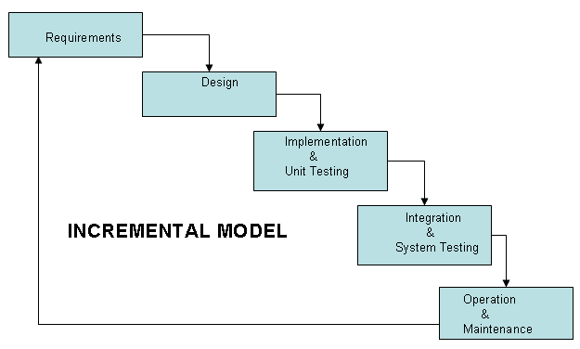

Fig: 1.1 Incremental Model of the activities in preparing the project template.

We divide the project in five Modules within incremental model:

**Module 1:** Homepage

**Module 2:** User (Signup-login-logout)

**Module 3:** Members + Notification

**Module 4:** Course Category

**Module 5:** Achievement + About Us +Ratings Table

Following ***Project Scope may*** include

1. Online registration portal for student’s information registration.
2. Downloading the lecture, document, course details etc.
3. Online teaching-learning process
4. Effectiveness education sharing
5. Access of multiple types of documents (video, audio, documents, etc.)
6. Community based and user-centric.
7. Students gives the test, teacher publish the result.

**1.5 GANTT CHART AND MILESTONE**

Table 1.1 presents the Gantt chart of the project where Table 1.2 presents the milestone of the proposed project.

Table 1.1 Gantt chart of Incremental Model

|  |  |  |  |  |  |  |  |  |  |  |  |  |  |  |
| --- | --- | --- | --- | --- | --- | --- | --- | --- | --- | --- | --- | --- | --- | --- |
| **Project Activities** | | **2019** | | | | | | | | | | | | |
| **Jan** | **Feb** | **Mar** | **Apr** | **May** | **June** | **Jul** | **Aug** | **Sep** | **Oct** | **Nov** | **Dec** |
| **1** | - **Background Study**  **- Requirement**  **Collection & Analysis**  **- Planning** |  |  |  | **1** |  |  |  |  |  |  |  |  |
| **2** | **Module 1** |  |  |  |  | **2** |  |  |  |  |  |  |  |
| **3** | **Module 2** |  |  |  |  |  | **3** |  |  |  |  |  |  |
| **4** | **Module 3** |  |  |  |  |  |  |  | **4** |  |  |  |  |
| **5** | **Module 4** |  |  |  |  |  |  |  |  |  | **5** |  |  |
| **6** | **Module 5** |  |  |  |  |  |  |  |  |  |  | **6** |  |
| **7** | **- Implement & Testing**  **- Report Presentation** |  |  |  |  |  |  |  |  |  |  |  | **7** |

Table 1.2 Project Milestones

|  |  |
| --- | --- |
| **Milestone** | **Dates** |
| **- Background Study**  **- Requirement Collection & Analysis**  **- Planning** | **April 2019** |
| **Module 1** | **22nd March 2019** |
| **Module 2** | **20th May 2019** |
| **Module 3** | **23rd August 2019** |
| **Module 4** | **15th October 2019** |
| **Module 5** | **31st December 2019** |
| **- Implement & Testing**  **- Report Presentation** | **December 2019** |

**1.6 SUMMARY AND OUTLINE**

This project is aimed at developing an education platform that makes knowledge available to users or learners and disregards time restrictions. This chapter presents the introduction about the project. Here includes Problem statements, objectives,

methodology and Gantt chat of the project. Firstly the introduction part presents why we develop this system. Also given description about portal. Study from other portal, we are given some problem statement and also the significant of this problem which is here on our system. In objective part it describes about some main concepts of this project. The main objective is to design and develop of an education portal system.

**Chapter 1:** Presents the introduction includes Problem statements, objectives, methodology and Gantt chat of this project. Where presents why we develop this system.

**Chapter 2:** Presents the depth Background study of this portal and comparison between two popular education portal systems.

**Chapter 3:** Represents detail analysis of the project, and design of the overall System and graphical representation by the "flow" diagram, “Relationship” and “Use Case” diagram.

**Chapter 4**: show and identify a fully documented operational system setup and testing that is implemented on this education portal.

**Chapter 5:** present the system results and discussion about the portal. The system results and necessary sections and diagram for system result and implementation given on this section.

**Chapter 6:** This chapter includes conclusion, outcomes, limitation, and recommendation about this project.

**CHAPTER TWO**

**BACKGROUND STUDY**

**2.1 OVERVIEW**

In order to conceptualize and build the project framework, we surveyed different sources of information. We study on various educational platforms and the services they offer. Also, what kind of technology and level of interaction they involve.

In depth study on recent literatures is conducted. This chapter presents the available projects, algorithms, techniques, and studies of the relevant project. Comparative analysis of the available strategies is also presented in this chapter with recent limitations and potential applications of the proposed project.

**2.2 BACKGROUND STUDY**

In this section we compare two popular education portal systems. There are:

1. Khan academy
2. Udemy.com

Khan Academy is a non-profit(Khan Academy: About, 2015) educational organization created in 2008 by Salman Khan with the goal of creating a set of online tools that help educate students(Nonprofit Explorer, 2015).The organization produces short lessons in the form of videos(One Man, One Computer, 10 Million Students: How Khan Academy Is Reinventing Education, 2015). Its website also includes supplementary practice exercises and materials for educators. All resources are available to users of the website. The website and its content are provided mainly in English, but are also available in other languages including Spanish, Portuguese, Hebrew, Italian, Russian, Chinese, Turkish, French, Bengali, Hindi, Georgian and German.

The main concepts of Khan Academy are:

1. Khan Academy's website aims to provide a personalized learning experience, mainly built on the videos which are hosted on YouTube.
2. The website is meant to be used as a supplement to its videos, because it includes other features such as progress tracking, practice exercises (KHAN ACADEMY INC, 2015) and teaching tools. (Khan Academy, PCMAG, 2015) The material can also be accessed through mobile applications (How Are Teachers and Students Using Khan Academy? Mind Shift, 2015).
3. The videos display a recording of drawings on an electronic blackboard, which are similar to the style of a teacher giving a lecture.

Another education portal system, Udemy.com, is an online learning platform. It is aimed at professional adults (Fitzpatrick & Alex 2016). Unlike academic massive open online course (MOOC) programs which are driven by traditional collegiate coursework, Udemy uses content from online content creators to sell for profit (Lomas, Natasha &TechCrunch, 2014). Udemy provides tools which enable users to create a course promote it and earn money from student tuition charges.

No Udemy courses are currently credentialed for college credit; students take courses largely as a means of improving job-related skills (Carr, David F et.al, 2013). Some courses generate credit toward technical certification. Udemy has made a special effort to attract corporate trainers seeking to create coursework for employees of their company (Carr, David F et.al, 2013). As of 2018, there are more than 100,000 courses on the website (Groden & Claire, 2016).

Main features of the Udemy.com are presented below.

1. Udemy serves as a platform that allows instructors to build online courses (Finder & Alan, 2016) on topics of their choosing.
2. Using Udemy’ s course development tools they can upload video, PowerPoint presentations, PDFs, audio, zip files and live classes to create courses. Instructors can also engage and interact with users via online discussion boards.
3. With Udemy for Business, organizations can also create custom learning portals for corporate training. (Empson & Rip, 2013)

Table 2.1 Comparison among Khan Academy, Udemy.Com and RAMR School

|  |  |  |
| --- | --- | --- |
| **Khan Academy** | **Udemy.com** | **RAMR School  (proposed system)** |
| To provide a personalized learning experience, mainly built on the videos which are hosted on YouTube. | To build online courses on topics of their choosing. | It will provide users a point of access to various educational tools and facilities. |
| The website is meant to be used as a supplement to its videos | Udemy uses content from online content creators to sell for profit. | Through this system the students will be able to access information resources and materials. |
| They skip the lessons which will be affecting to gain the knowledge | They skip the lessons which will be affecting to gain the knowledge | They learn all the lessons one by one lessons which will be helping to gain the proper knowledge |
| The organization produces short lessons in the form of videos. | Udemy courses are currently credentialed for college credit; students take courses largely as a means of improving job-related skills. | The organization produces largely lessons in the form of resources and materials. |

**2.3 SUMMARY**

This chapter presents in depth Background study of the conducted project. Two popular education portals, Khan Academy and Udemy.com, are compared and presented in tabulated format. This chapter also presents recent gaps of related systems and potential applications of the proposed project**.**

**CHAPTER THREE**

**SYSTEM ANALYSIS & DESIGN**

**3.1 OVERVIEW**

This chapter we discuss about the method to develop and maintain the system that perform basic functions of this portal. The analysis and design are mainly base on understanding the portals processes by flow and relationship diagrams. The overall goal of analysis and design is to study procedural components and modules of this Project.

**3.2 SYSTEM ANALYSIS AND DESIGN**

For education portal design and analysis we design some diagram which provide the portal graphical structure.

**3.2.1 DATA FLOW DIAGRAM**

The figure in below shows Data Flow Diagram that is draw for Education portal. It contains three entities admin, teacher and student who will interact with the system. Also the system contain some process that represents the system to model. In between entities, process and data stores. Based on the diagram the admin take response and check response for registration which is stored on user data store. Student and teacher enter details for registration and after show response for registration they can view their dashboard process and access the system.

Following Figure 3.1 presents data flow diagram,

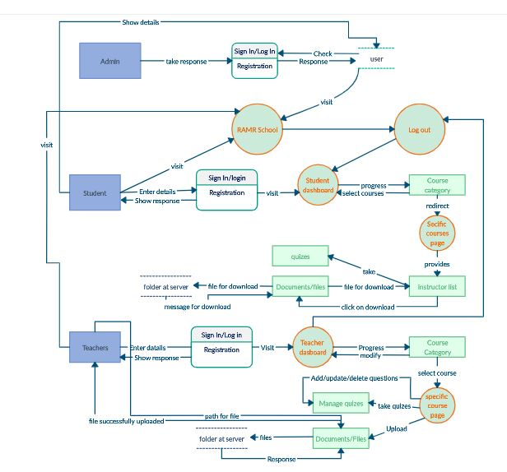

Figure 3.1 Data-Flow Diagrams

Based on Data flow diagram, the portal limitations as follows,

1. Access the courses.
2. Forget password on request.
3. View in admin home page.

**3.2.2 Entity Relationship Diagram**

The following Entity-Relationship (E-R) diagram represents the model of education portal. The e-r diagram of education portal system shows all the visual instrument of database tables and the relationships between structured groups of Education portal functionalities. The main entities of the system are sign in, login, student, teacher, ramr, member upload document, teacher degree, teacher info course category and notification. The details of students and teachers is store into the Student and teacher tables respective with all tables. Each entity contain primary key and unique key. All the entities are normalized and reduce duplicity of records. We have implemented indexing on each tables of Education portal tables for first query execution.

The following figure is presents entity-relationship diagram for database.

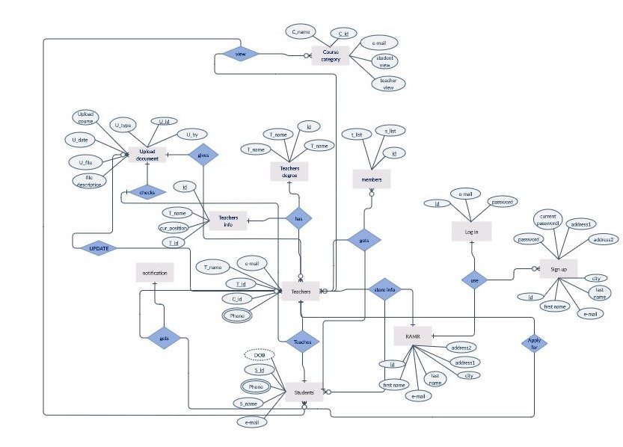

Figure 3.2 Entity-Relationship diagram

* + 1. **USE CASE DIAGRAM**

This use case diagram is a graphical depiction of the interactions among the elements of education portal. It represents the methodology used in system analysis to identify and system requirements of education portal. The system has three actors’ admin, teacher and student who perform the different type of use cases such as login manage faculty, upload material, verify accounts, manage learning, study learning materials etc. operations. All the elements are shown on the diagram below.

The following figure is presents use case diagram,

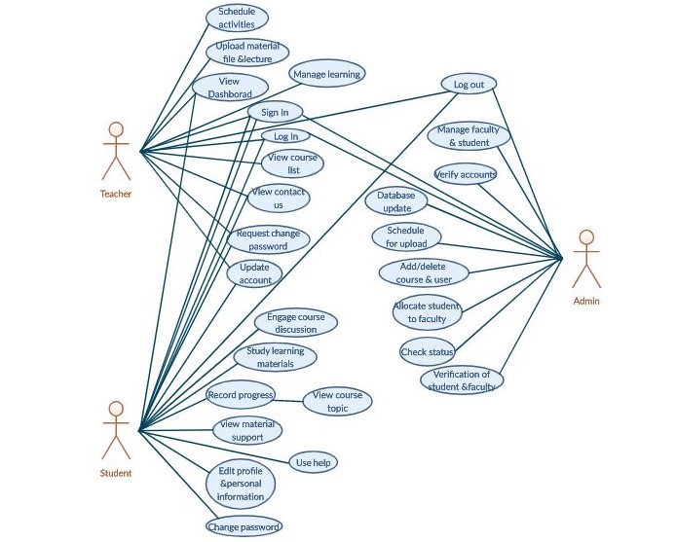

Figure 3.3 Use case diagram

**3.2.3 SITE MAP**

The following site map shows the plan and visualize education portal information architecture. The system home option show up so often so that user can interact the site and access its storage features, such as sign in, log in, course category, notification, members and logout.

The following figure is presents site-map diagram for proposed project,

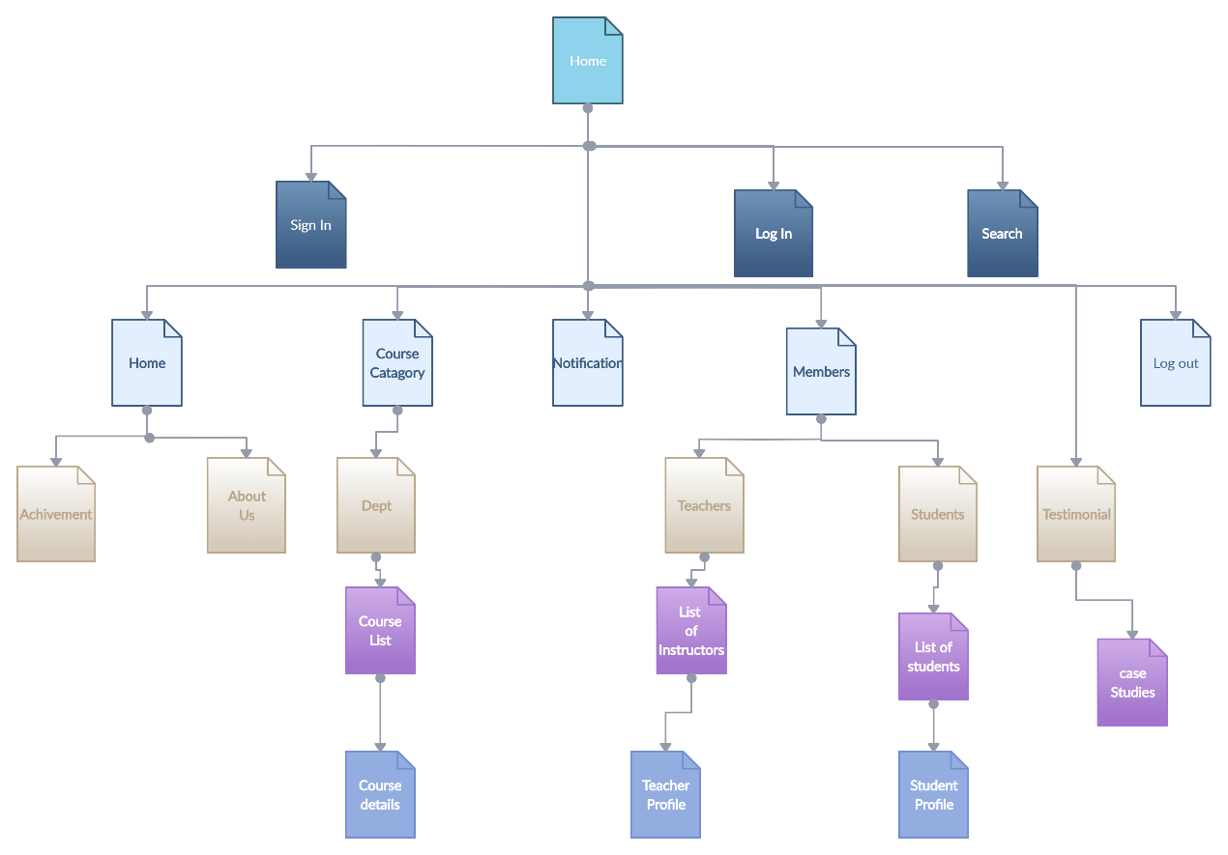

Figure 3.4 Site-Map diagrams

* + 1. **SCHEMATIC DIAGRAM**

Above figure is shown the education portal structure of database. In this diagram it shows the database objective and their relationship with each other. The figure shows system tables along with their data types, relationships between the tables, as well as their primary keys and foreign keys. The following figure is presents schematic diagram of database for this portal,

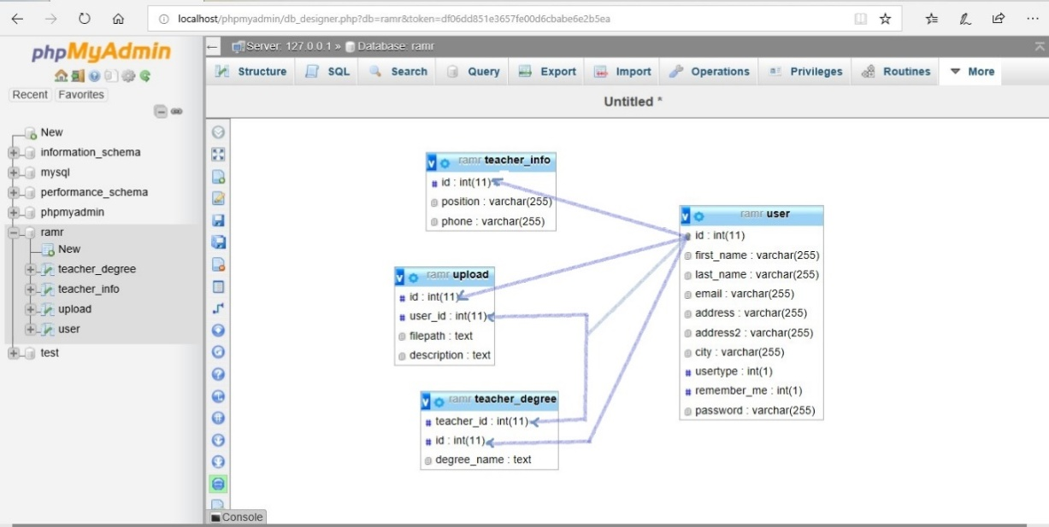

Figure 3.5 Schematic view of database

**3.3 SUMMARY**

In this chapter, we represent detail analysis of the project, and design of the overall system. For graphical representation of the "flow" of data through an information system, modeling its process aspects. Figure 3.1 presented the data flow diagram and Figure 3.2 is presented the entity-relationship diagram, Figure 3.3 is presented the use case diagram, Figure 3.4 is presented the site map diagram of this project, Figure 3.5 is presented the schematic diagrams. This part describing the data or information aspects of system process requirements.

**CHAPTER FOUR**

**SYSTEM SETUP, IMPLEMENTATION, & TESTING**

**4.1 OVERVIEW**

The main objective of this chapter is to show and identify a fully documented operational system setup and testing that is implemented on this education portal.

**4.2 SYSTEM SETUP**

The operation of system setup for the portal we used PHP, APACHE and MySQL. The combination of PHP and MySQL from the most widely used open source scripting language and database on the web today. The process of system setup can be explained as follows:

**Apache**: The portal core program that performs the hosting services. Apache program is hosting the portal HTML file and other static web documents.

**MySQL:** It provides a database that will contain all web content. Dynamic web pages need to store data from time to time thus require a database.

**PHP:** This is perhaps the language for creating dynamic web content. For system setup the following step as follows:

* **Installing the XAMPP software:**

First we download the latest version of XAMPP server. The package comes with the installments of Apache, MySQL and PHP. Then we run the .exe file in the XAMPP setup that we have download. We will receive installation prompts that are straightforward. Maintaining the default values to continue with installation. After complete the installation these will come in handy in storing HTML or PHP files.

* **Create an HTML or PHP page:**

For testing the system use a web development program such as Notepad++ to develop the portal PHP pages. GO to ‘save’ or ‘save as’ and gave the portal different pages name and add the extensions. php set to be the destination of the saved file. Return to Webserver and click refresh to update these changes. Our portal data will be updated in the www directory. For testing the portal we go to ‘https://localhost/index.php’ through our browser.

* **Configuring MySQL:**

Configuring our MySQL database by opening the phpMyAdmin panel in the menu. Through the admin username automatically sets to “root” after which we are prompted. We are customize the MySQL databases and create tables based on our system preference.

To run the application from the internet, the modify files will have to be uploaded to a web server running Apache/MySQL and access through a browser.

**4.3 IMPLEMENTATION**

To design the Online Portal PHP is used where MySQL is used in designing the database for the registration/signup processes. It consists of the names of student or teacher, course code and overall registration information.

* + 1. **GRAPHICAL USER INTERFACE**

According to the graphical user interface of the log in page, presented in Figure 4.1, algorithm and flowchart are shown in Figure 4.2 and Figure 4.3

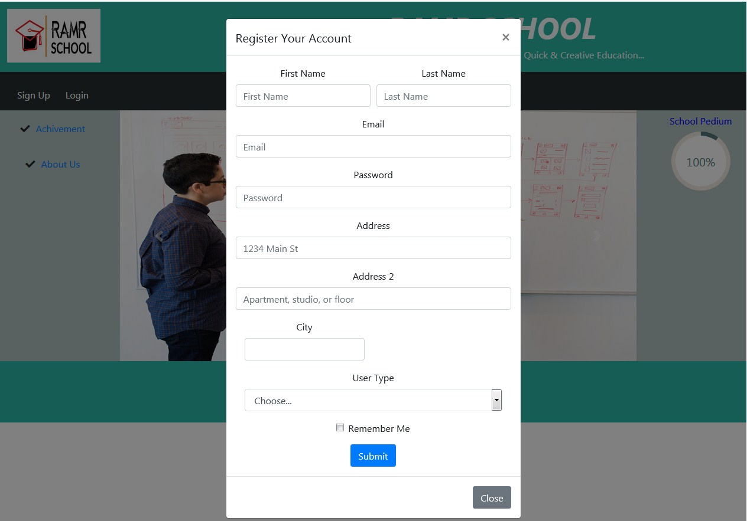

Figure 4.1 log in page

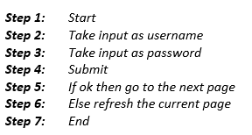

Figure 4.2 Algorithm of Log in page

From the algorithm the flowchart diagram shows in the below,

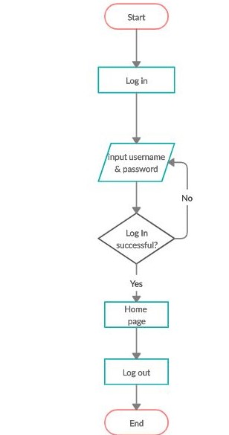

Figure 4.3 Flowchart for log in.

**4.4 TESTING**

This section present the system testing. The system testing provides the process of executing the system with the intent of finding errors. Also the scope of software testing includes executions of code in various environments and conditions. Testing stages of the project can be explained as component or unit testing, system testing, acceptance testing.

Testing stages of the project can be explained as follows:

**4.4.1 Test Cases**

User interface: Sign Up/Login

Operation: System Login

Table 4.1 System testing stages

|  |  |  |  |  |
| --- | --- | --- | --- | --- |
| **Task** | **Action** | **Input** | **Expected Output** | **Status** |
| Signup | Type User Name, Email, Password and click submit button. | Akhter  [akhter@gmail.com](mailto:akhter@gmail.com)  akhter11 | Signup to the System with appropriate process. | Pass |
| Login | Type User Email, Password and click submit button. | [akhter@gmail.com](mailto:akhter@gmail.com)  akhter11 | Login to the System with appropriate process. | Pass |
| Signup  (invalid) | Type User Name and keep Password empty and click submit button. | [aftab@gmail.com](mailto:aftab@gmail.com) | Display error message “enter a password” and try again. | Pass |
| Login  (invalid) | Type valid User Name and invalid Password and click. | Akhter  [akhter@gmail.com](mailto:akhter@gmail.com)  akters12 | Display error message “incorrect password” and try again. | pass |
| Login  (invalid) | Type both user name and password invalid. | [aftab@gmail.com](mailto:aftab@gmail.com)  akter122 | Display error message “invalid user name” and try again. | pass |

**4.5 SUMMARY**

This chapter discuss about setup, implementation, testing strategy. Further, problem faced in the software development process also discussed here. Also Figure 4.1 represents the system log in page, Figure 4.2 represents algorithm of log in page Figure 4.3 represents system flow chart of log in page and Table 4.1 represents the system testing stage.

**CHAPTER FIVE**

**RESULT ANALYSIS**

**5.1 OVERVIEW**

This section should present the system results and discussion about the portal. The system results and necessary sections and diagram for system result and implementation given on this section. Also discuss about them.

**5.2 RESULT PRESENTATION**

This section present the results or outputs. Also the system necessary diagrams, figures.

**5.2.1 Graphical user interface (GUI):**

* **Homepage:**

This following figure shows in below for our portal home page. When a user first visit the portal they can see this view. This page the highlight elements is a user cannot access the portal without sign in or registration. They must need sign in for the portal. Also our portal user type is two:

1. Teacher & 2. Student

So user first choose which type he/she wanted to registration. And then they can fill up the details and after admin access the registration then they can use the portal. Also it has log in option after complete the registration a user can log in anytime for the portal after logout.

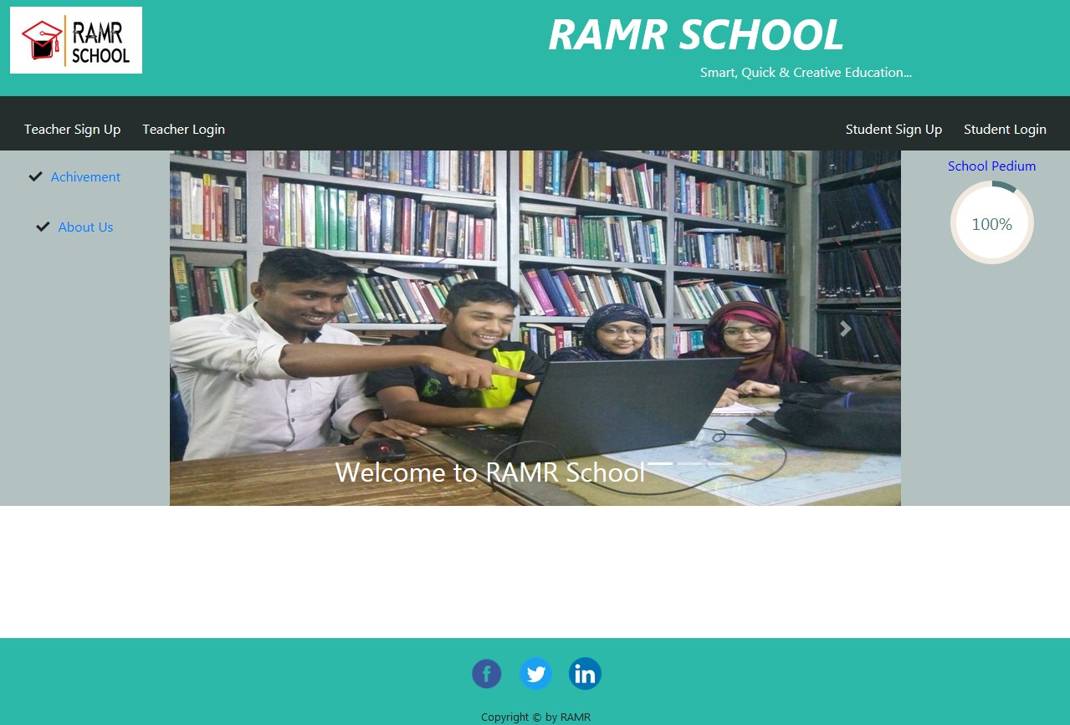

Figure 5.1 RAMR portal home page before sign up.

* **Sign Up/Registration page:**

The figure which is given on below is registration page or sign up page. A user must need to registration for this portal. Without sign up the user cannot access the portal. So he/she fill up all the details which are given on following figure.

To design the Online Portal PHP is used where MySQL is used in designing the database for the registration/signup processes. It consists of the names of student or teacher, course code and overall registration information.

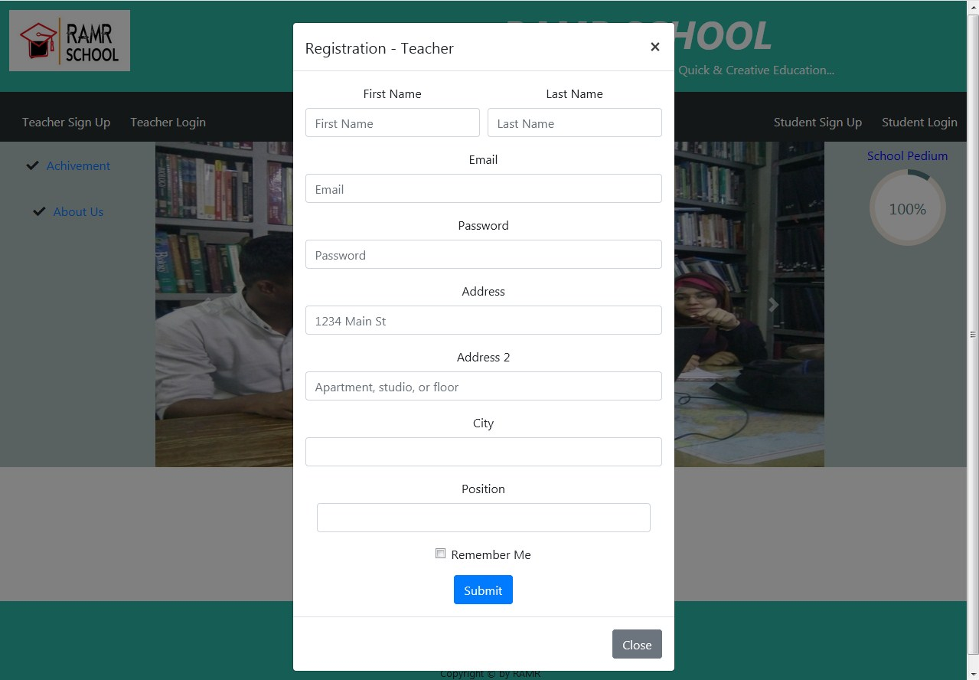

Figure 5.2 Registration/Sign up page.

* **Log In Page:**

When a complete the registration they can log in the system anytime which is given on following figure. A user must fill the instruction and then submit. If the information is correct then the user enter the portal otherwise it show the error and need to reload the page. The log in process information store in database table.

The following figure is present the log in page,

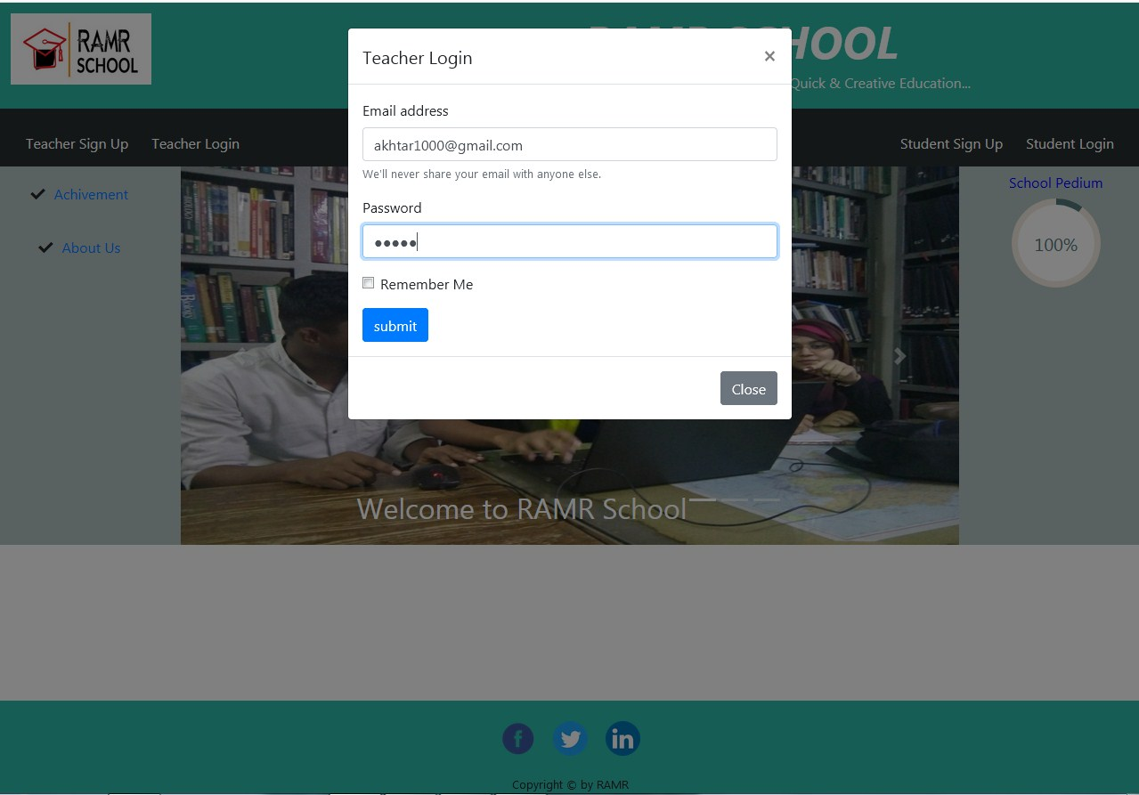

Figure 5.3 Log in page.

* **Home Page After Sign Up/Log In:**

After user Sign up/log in for the portal they can view the following figure which is shown in below. The user can see all the features of the portal and also they access all of them.

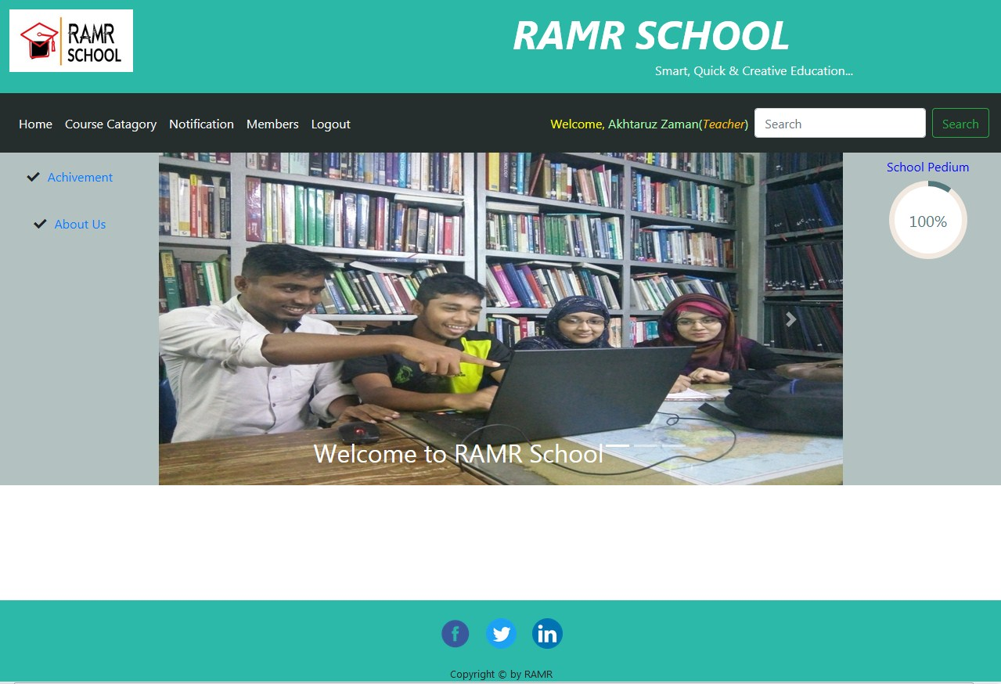

Figure 5.4 Home page after Sign Up/Log In.

* **Course Category:**

The portal course category first the user is seen the list of department. The user can choose which type of course he/she want.

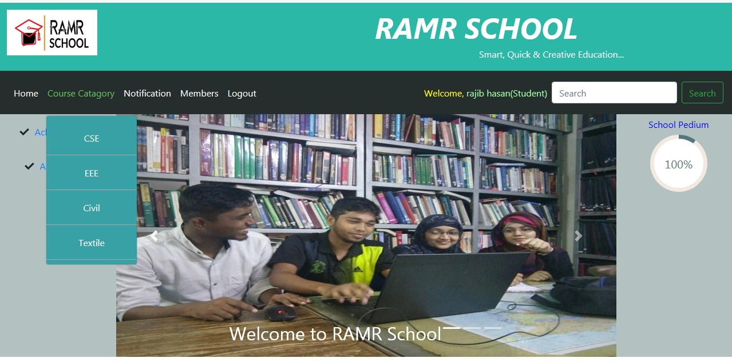

Figure 5.5 Course Category page

After click the chosen dept. from the department list the user can view the course list. The following figure is for course list of the portal,

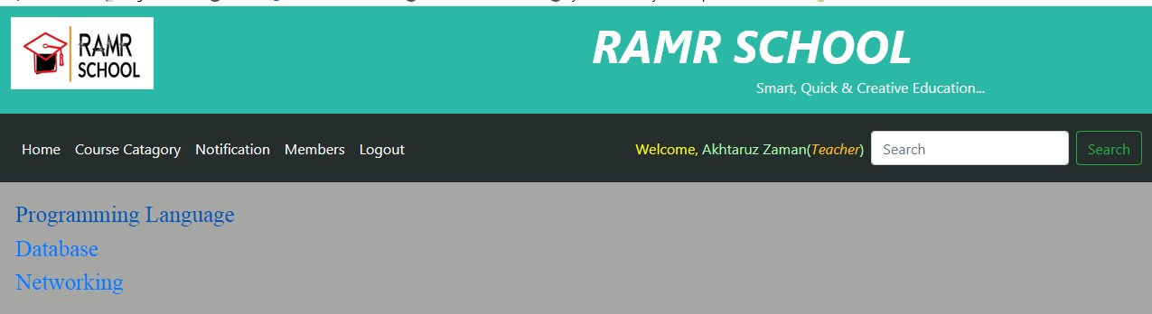

Figure 5.6 Course list

* **Course category as teacher view:**

When a teacher visit the course category they can view their profile. On their dashboard they upload the document file. Also teacher can delete and edit the document. The upload file list and information is store in database table. The following figure is teacher view for course category.

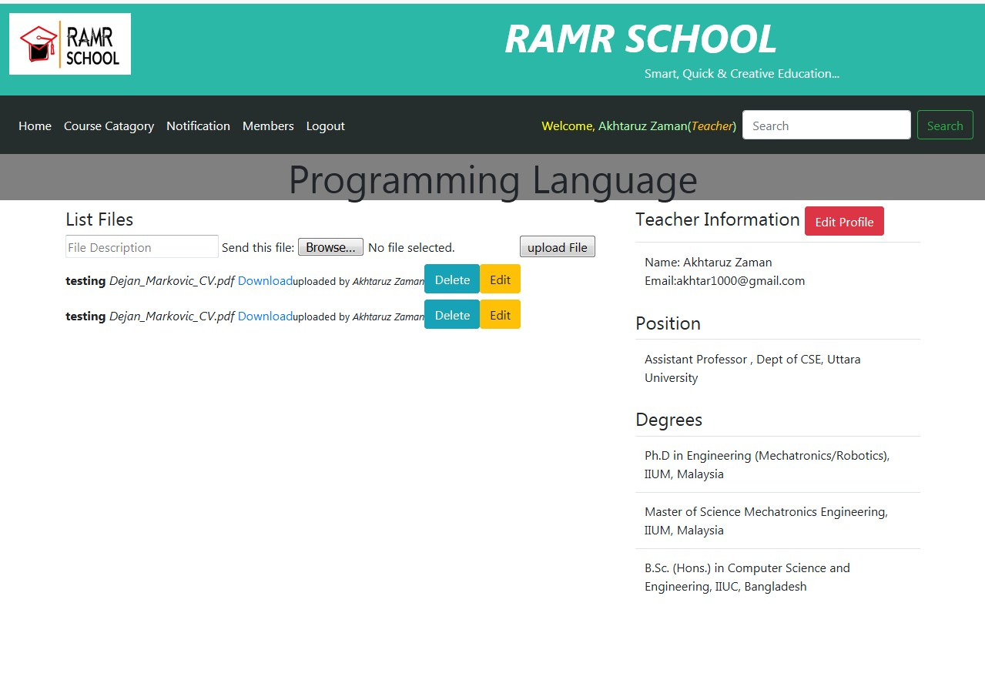

Figure 5.7 Teacher dashboard for course category.

* **Course Category as Student View:**

This section is student view for course. The student after click his/her choses course they can first seen the teacher list. The student can chose his/her chose teacher and view the course documents. The following figures are course view for student.

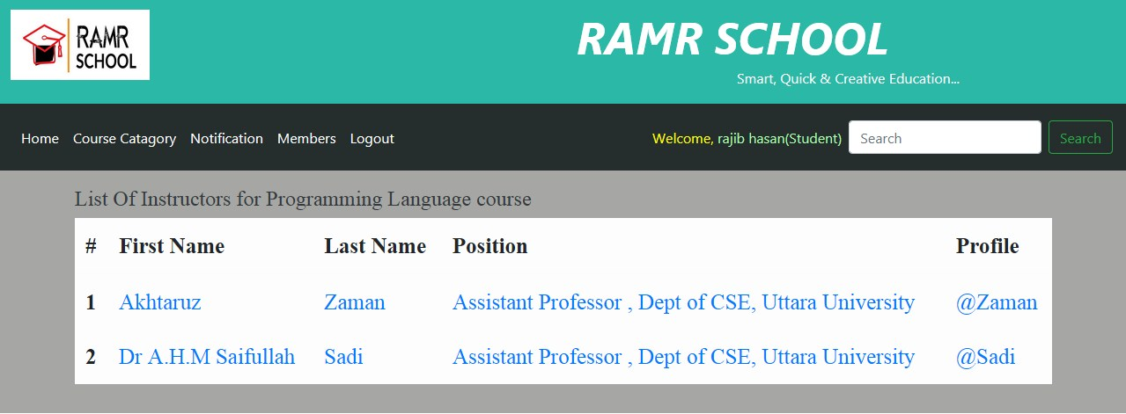

Figure 5.8 Teachers list for course.

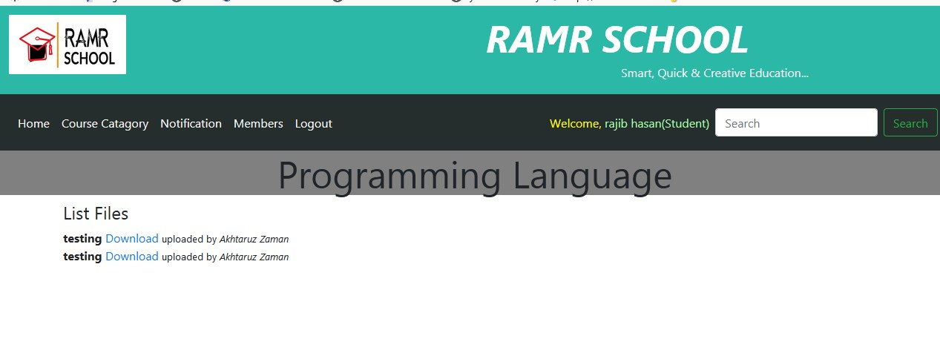

Figure 5.9 Students dashboard for course.

**5.3 DISCUSSIONS**

This section is for results analysis. We give some graphical user interface image. Also we are discuss about our portal features by some image. Overall this image we wanted to show our system view. We know education portal makes knowledge available to user or learners. We develop this system because we want the user can create new learning opportunities to achieve the ultimate goals according to their environment. The system will be developed based on open source platforms, it will satisfy the user requirements and allow them to reuse, study, and distribute. The portal has included the common features and services of educational portal.

**5.5 SUMMARY**

This chapter is about the system result. In this chapter we present some image of our portal which we are implemented on our project objective. Figure 5.1 presents RAMP portal home page before sign up**,** Figure5.2 presents system registration/sign up page, Figure 5.3 presents system log in page, Figure 5.4 presents home page after sign up/log In, Figure 5.5 presents course category page, Figure 5.6 presents course list, Figure 5.7 presents teacher dashboard for course category, Figure 5.8 represents the teacher list for course, Figure 5.9 presents The Student dashboard for course. And in the end we discuss about the result and main objective to create this project.

**CHAPTER SIX**

**CONCLUSION & RECOMMENDATIONS**

Education portal is basically a web-based system that makes knowledge available to users or learners which are defined the skill acquired by a person through experience or education. Knowledge is exchanged among people, friends or family members, an organization or community through sharing knowledge activity. The current technology methods are using this knowledge and store that knowledge using repository. It is widespread use of the internet which is understood educational portal system. The project provides new learning opportunities to achieve the ultimate goals according to their environment and it is efficient and low cost. The system will be developed based on open source platforms, it will satisfy the user requirements and allow them to reuse, study, and distribute. Nowadays education portal system has face some problem which are adjustment and adaptation problems with traditional teaching in classroom environment and trained and expert instructors are not enough for the usage of technologies. These projects provide necessary information for students by the system to improve their academic performance and excellence. Teachers can provide all the necessary information resource material to their students and able to get the student information from the website. The portal has included the common features and services of educational portal. Moreover the project will have positive effect to e-lifestyle for young generations towards learning.

* 1. **PROJECT OUTCOMES**

The project become an effective resource and knowledge sharing between teachers and students. Now the necessary information for students can be provided by this system to improve their academic performance and excellence. It offers educational services to users. This portal can be community of practice and a service to maintain the knowledge. The outcomes should reflects the objective. The outcome of this project is presented below.

1. A complete Graphical User Interface (GUI).
2. A complete database table.
3. Main product is web application as Education Portal for tertiary level.

**6.2 LIMITATIONS OF THE PROJECT**

We can point some limitation on this portal. It is important to get people’s feedback to really understand how we can improve rapidly, and it is important to let them know what is been done.

The limitations of this following project are:

1. Video conferencing module is not supported in the current system.
2. The system can’t access the virtual classroom.
3. The website has no online chatting facilities.

**6.3 RECOMMENDATIONS**

Education portal is web-based system that makes knowledge available to users or learners. The system provides necessary information for students by the system to improve their academic performance and excellence. Based on the study, it can be recommended that the education portal be made to

1. Accommodate additional features required by the users.
2. The general functionality of the portal should also be improved upon such areas as images/video upload, save page, upload .exe files and similar features.
3. Provides new learning opportunities to achieve the ultimate goals according to their environment.
4. It will satisfy the user requirements and allow them reuse, study and distribute.
5. The portal has include common features and services of education portal.

**REFERENCES**

"Khan Academy: About". Khan Academy. Retrieved 2013-08-15.

"Nonprofit Explorer – ProPublica". ProPublica. Retrieved 2015-11-07.

"One Man, One Computer, 10 Million Students: How Khan Academy Is Reinventing Education". Forbes. Retrieved 2015-11-07.

"Nonprofit Explorer – KHAN ACADEMY INC – ProPublica'". ProPublica. Retrieved 2015-09-22.

"Khan Academy". PCMAG. Retrieved 2015-11-07.

"How Are Teachers and Students Using Khan Academy?” Mind Shift. Retrieved 2015-11-07.

Fitzpatrick, Alex (February 12, 2016). "Udemy Thinks It's Cracked the Future of Online Education". Time. Retrieved 25 September 2016.

Lomas, Natasha. Online Learning Marketplace Udemy Raises $32M to Scale Up Internationally. TechCrunch. May 8, 2014

Carr, David F. Udemy Comes To Corporate Training Information Week. April 16, 2013

Groden, Claire (June 22, 2016). "Udemy's Exodus, Amazon's Gain". Inverse. Retrieved 25 September 2016.

Finder, Alan (September 25, 2013). "A Surge in Growth for a New Kind of Online Course". New York Times. Retrieved 25 September 2016.

Empson, Rip. "With Over 6,000 Courses Now Live, Udemy Brings Its Learning Marketplace To iOS To Let You Study on the Go". TechCrunch. AOL. Retrieved 4 May 2013.